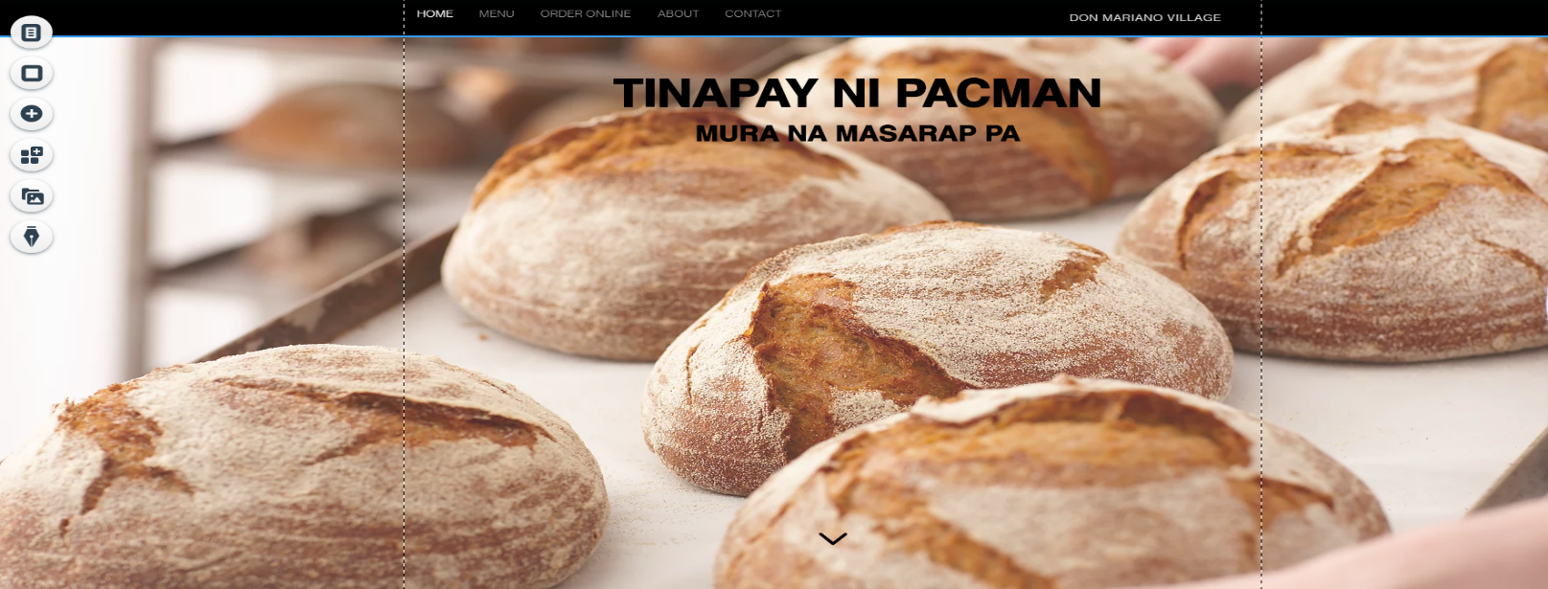

* This is the menu or home of the website and it consist of all of the thing in the website

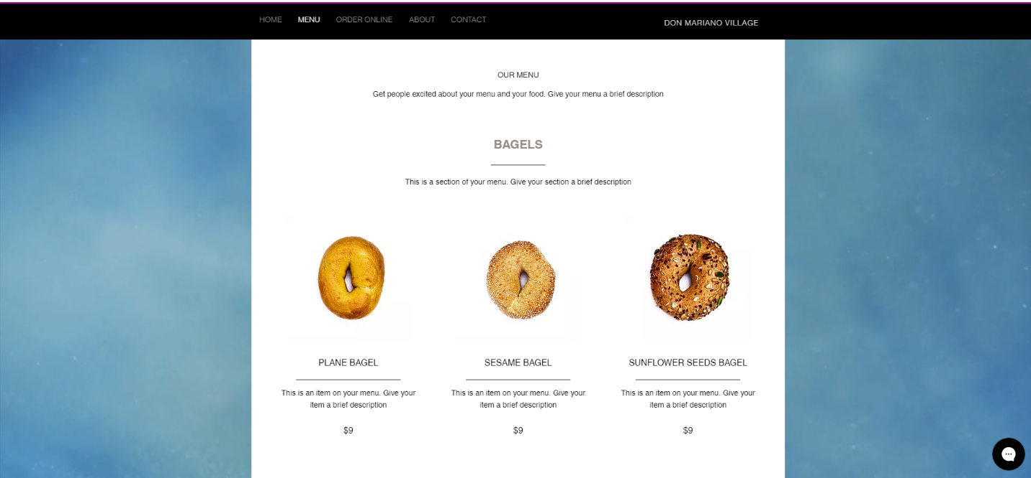

* The menu tab is displays all of the menu in our products and show also the price of the product

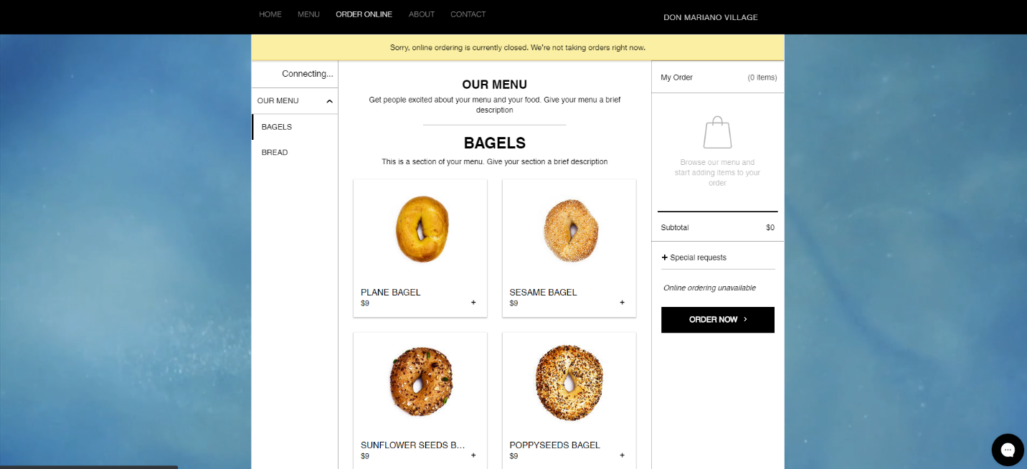

* this part of the website who shows in how to be able ordering using online

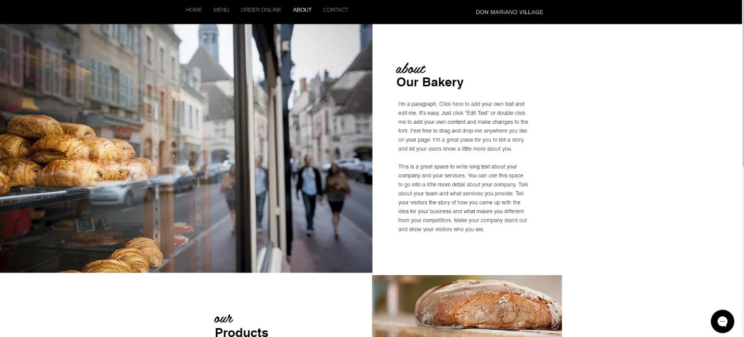

* this is the part who shows the all of the other information in my websites and shows also the place

* This is the part of the website in how to order online and also see our place using google maps and shows also the founder of the business company